Air Cargo Transport

This is an analysis of the performance of a forward planning agent in formulating a plan to move cargo between airports. The agent is given an initial start state with the locations of cargoes and planes at different airports. The agent is given a set of potential actions it can take, and the agent is given a goal state to reach. More background regarding forward planning agents and the air cargo transport problem can be found in the textbook Artificial Intelligence: A Modern Approach (Russell/Norvig) in chapter 10 of the 3rd edition (chapter 11 of the 2nd edition: http://aima.cs.berkeley.edu/2nd-ed/newchap11.pdf). The agent was tested with four problems of increasing complexity using 11 different search algorithms. Details are given below.

Problems:
1. Air Cargo Problem #1 (2 Cargoes, 2 Planes, 2 Airports, 2 Goals)

Init(At(C1, SFO) ∧ At(C2, JFK)
∧ At(P1, SFO) ∧ At(P2, JFK)
∧ Cargo(C1) ∧ Cargo(C2)
∧ Plane(P1) ∧ Plane(P2)
∧ Airport(JFK) ∧ Airport(SFO))

Goal(At(C1, JFK) ∧ At(C2, SFO))

2. Air Cargo Problem #2 (3 Cargoes, 3 Planes, 3 Airports, 3 Goals)

Init(At(C1, SFO) ∧ At(C2, JFK) ∧ At(C3, ATL)
∧ At(P1, SFO) ∧ At(P2, JFK) ∧ At(P3, ATL)
∧ Cargo(C1) ∧ Cargo(C2) ∧ Cargo(C3)
∧ Plane(P1) ∧ Plane(P2) ∧ Plane(P3)
∧ Airport(JFK) ∧ Airport(SFO) ∧ Airport(ATL))

Goal(At(C1, JFK) ∧ At(C2, SFO) ∧ At(C3, SFO))
3. Air Cargo Problem #3 (4 Cargoes, 2 Planes, 4 Airports, 4 Goals)

Init(At(C1, SFO) ∧ At(C2, JFK) ∧ At(C3, ATL) ∧ At(C4, ORD)
∧ At(P1, SFO) ∧ At(P2, JFK)
∧ Cargo(C1) ∧ Cargo(C2) ∧ Cargo(C3) ∧ Cargo(C4)
∧ Plane(P1) ∧ Plane(P2)
∧ Airport(JFK) ∧ Airport(SFO) ∧ Airport(ATL) ∧ Airport(ORD))

Goal(At(C1, JFK) ∧ At(C2, SFO) ∧ At(C3, JFK) ∧ At(C4, SFO))
4. Air Cargo Problem #4 (5 Cargoes, 2 Planes, 4 Airports, 5 Goals)
Init(At(C1, SFO) ∧ At(C2, JFK) ∧ At(C3, ATL) ∧ At(C4, ORD) ∧ At(C5, ORD)
∧ At(P1, SFO) ∧ At(P2, JFK)
∧ Cargo(C1) ∧ Cargo(C2) ∧ Cargo(C3) ∧ Cargo(C4) ∧ Cargo(C5)
∧ Plane(P1) ∧ Plane(P2)
∧ Airport(JFK) ∧ Airport(SFO) ∧ Airport(ATL) ∧ Airport(ORD))

Goal(At(C1, JFK) ∧ At(C2, SFO) ∧ At(C3, JFK) ∧ At(C4, SFO) ∧ At(C5, JFK))
Potential Actions:
Action(Load(c, p, a),
Precondition: At(c, a) ∧ At(p, a) ∧ Cargo(c) ∧ Plane(p) ∧ Airport(a)
Effect: ¬ At(c, a) ∧ In(c, p))

Action(Unload(c, p, a),
Precondition: In(c, p) ∧ At(p, a) ∧ Cargo(c) ∧ Plane(p) ∧ Airport(a)
Effect: At(c, a) ∧ ¬ In(c, p))

Action(Fly(p, from, to),
Precondition: At(p, from) ∧ Plane(p) ∧ Airport(from) ∧ Airport(to)
Effect: ¬ At(p, from) ∧ At(p, to))

Search Algorithms Tested:
1. Breadth First Search
2. Depth First Graph Search
3. Uniform Cost Search
4. Greedy Best First Graph Search With Unmet Goals Heuristic
5. Greedy Best First Graph Search With Level Sum Heuristic
6. Greedy Best First Graph Search With Max Level Heuristic
7. Greedy Best First Graph Search With Set Level Heuristic
8. A* Search With Unmet Goals Heuristic
9. A* Search With Level Sum Heuristic
10. A* Search With Max Level Heuristic
11. A* Search With Set Level Heuristic
Results
Problem One:
Search Algorithm | Actions | Expansions | Goal Tests | New Nodes | Path Length | Time (Seconds)
Breadth First | 20 | 43 | 56 | 178 | 6 | 0.039
Depth First | 20 | 21 | 22 | 84 | 20 | 0.013
Uniform Cost | 20 | 60 | 62 | 240 | 6 | 0.038
Greedy Best First with  Unmet Goals Heuristic | 20 | 7 | 9 | 29 | 6 | 0.004
Greedy Best First with  Level Sum Heuristic | 20 | 6 | 8 | 28 | 6 | 0.435
Greedy Best First with  Max Level Heuristic | 20 | 6 | 8 | 24 | 6 | 0.194
Greedy Best First with  Set Level Heuristic | 20 | 6 | 8 | 28 | 6 | 1.009
A* Search With Unmet Goals Heuristic | 20 | 50 | 52 | 206 | 6 | 0.026
A* Search With Level Sum Heuristic | 20 | 28 | 30 | 122 | 6 | 0.436
A* Search With Max Level Heuristic | 20 | 43 | 45 | 180 | 6 | 0.217
A* Search With Set Level Heuristic | 20 | 33 | 35 | 138 | 6 | 0.607

Problem Two:

Search Algorithm | Actions | Expansions | Goal Tests | New Nodes | Path Length | Time (Seconds)
Breadth First | 72 | 3343 | 4609 | 30503 | 9 | 0.596
Depth First | 72 | 624 | 625 | 5602 | 619 | 0.801
Uniform Cost | 72 | 5154 | 5156 | 46618 | 9 | 1.201
Greedy Best First with  Unmet Goals Heuristic | 72 | 17 | 19 | 170 | 9 | 0.044
Greedy Best First with  Level Sum Heuristic | 72 | 9 | 11 | 86 | 9 | 0.480
Greedy Best First with  Max Level Heuristic | 72 | 27 | 29 | 249 | 9 | 0.755
Greedy Best First with  Set Level Heuristic | 72 | 9 | 11 | 84 | 9 | 1.996
A* Search With Unmet Goals Heuristic | 72 | 2467 | 2469 | 22522 | 9 | 1.177
A* Search With Level Sum Heuristic | 72 | 357 | 359 | 3426 | 9 | 11.382
A* Search With Max Level Heuristic | 72 | 2887 | 2889 | 26594 | 9 | 65.078
A* Search With Set Level Heuristic | 72 | 1037 | 1039 | 9605 | 9 | 161.149

Problem Three:
Search Algorithm | Actions | Expansions | Goal Tests | New Nodes | Path Length | Time (Seconds)
Breadth First | 88 | 14663 | 18098 | 129625 | 12 | 1.708
Depth First | 88 | 408 | 409 | 3364 | 392 | 0.410
Uniform Cost | 88 | 18510 | 18512 | 161936 | 12 | 2.842
Greedy Best First with  Unmet Goals Heuristic | 88 | 25 | 27 | 230 | 15 | 0.087
Greedy Best First with  Level Sum Heuristic | 88 | 14 | 16 | 126 | 14 | 2.172
Greedy Best First with  Max Level Heuristic | 88 | 21 | 23 | 195 | 13 | 1.097
Greedy Best First with  Set Level Heuristic | 88 | 35 | 37 | 345 | 17 | 11.383
A* Search With Unmet Goals Heuristic | 88 | 7388 | 7390 | 65711 | 12 | 2.421
A* Search With Level Sum Heuristic | 88 | 369 | 371 | 3403 | 12 | 21.490
A* Search With Max Level Heuristic | 88 | 9580 | 9582 | 86312 | 12 | 355.126
A* Search With Set Level Heuristic | 88 | 3423 | 3425 | 31596 | 12 | 846.396

Problem Four:

Search Algorithm | Actions | Expansions | Goal Tests | New Nodes | Path Length | Time (Seconds)
Breadth First | 104 | 99736 | 114953 | 944130 | 14 | 10.872
Depth First | 104 | 35174 | 25175 | 228849 | 24132 | 1511.397
Uniform Cost | 104 | 11339 | 113341 | 1066413 | 14 | 15.650
Greedy Best First with  Unmet Goals Heuristic | 104 | 29 | 31 | 280 | 18 | 0.099
Greedy Best First with  Level Sum Heuristic | 104 | 17 | 19 | 165 | 17 | 2.843
Greedy Best First with  Max Level Heuristic | 104 | 56 | 58 | 580 | 17 | 4.332
Greedy Best First with  Set Level Heuristic | 104 | 107 | 109 | 1164 | 23 | 45.807
A* Search With Unmet Goals Heuristic | 104 | 34330 | 34332 | 328509 | 14 | 8.523
A* Search With Level Sum Heuristic | 104 | 1208 | 1210 | 12210 | 15 | 106.505
A* Search With Max Level Heuristic | 104 | 62077 | 62079 | 599376 | 14 | 1601.940
A* Search With Set Level Heuristic | 104 | 22606 | 22608 | 224229 | 14 | 9314.945

The results show that as the number of actions in each problems increased, the number of expansions increased considerably. This is illustrated in the chart below.
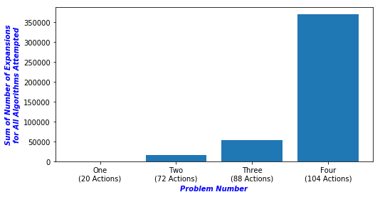

The results also show that the search time increases considerably as the number of actions increases.

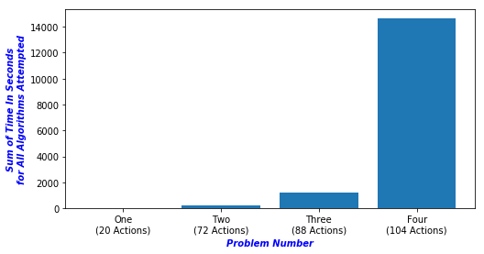

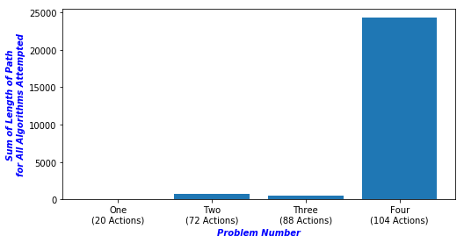
An initial comparison of the length of path with respect to the number of actions in each problem shows similar results to those above.

But, it is obvious in looking at the tables that with respect to path length, the Depth First Search algorithm gives path lengths that markedly skew the results. When the Depth First Search results are removed, the path length show a more steady increase with respect to the number of actions in each problem.

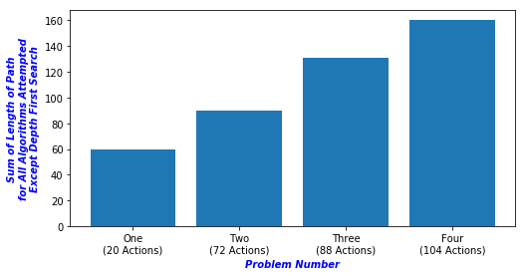

Q&A

Which algorithm or algorithms would be most appropriate for planning in a very restricted domain (i.e., one that has only a few actions) and needs to operate in real time?

If the the planning needs to be operated in real time, the agent must formulate a plan in a very short amount of time. In the first problem, which had the least amount of actions, almost all the algorithms gave an optimal path in less than a second, so it is possible that all of those algorithms would be acceptable depending on the specifics of the problem. The choice of algorithm would likely come down to a trade off between the speed of the algorithm vs. the optimal path always being found. Greedy Best First Search with Unmet Goals Heuristic was the fastest of the Algorithms tested, while Breadth First Search will always return the optimal path.

Which algorithm or algorithms would be most appropriate for planning in very large domains (e.g., planning delivery routes for all UPS drivers in the U.S. on a given day)

As the size the domain increases, finding an optimal path becomes unlikely or impossible within reasonable time constraints. Of the algorithms tested, Greedy Best First Search with Unmet Goals Heuristic was the only one to return a path in under one second for the fourth problem with the largest domain. It would likely be the best choice for even larger domains.

Which algorithm or algorithms would be most appropriate for planning problems where it is important to find only optimal plans?

If the only consideration is finding an optimal plan, Breadth First Search would be the most appropriate algorithm. It is guaranteed to find an optimal plan.

